Python Course final project
Python Translation of Unity Coded App
Tuner, metronome, BPM rollers, UI animations and splash screen

1. Purpose of the Work
It all started from the desire to create my own tuner-metronome app, without advertisements or subscriptions, and that would allow me to fully understand what lies behind this kind of application in terms of programming.
This report describes the original Unity C# scripts and their literal translation into a Python version. The translation is not intended to make the project executable in Unity, since it only uses C# as a code, but to preserve as faithfully as possible the structure, names, variables, methods, control flow, and logical behavior.
The parts depending on Unity, Android, TextMeshPro, AudioSource, Microphone, ScrollRect, Coroutine, and SceneManager were represented with stub classes, meaning minimal Python objects used to preserve the shape of the original code.

2. Original Files and Responsibilities
SCRIPT | RESPONSABILITY | OUTPUT/EFFECT
ControlloreRullo.cs | Manages a vertical numeric roller with snapping, invisible looping, and selected value handling. | Produces SelectedValue for hundreds, tens, or units.
GestoreTotaleBpm.cs | Combines 3 numeric rollers into a single BPM value. | Updates MetronomeController.SetBPM().
GuitarTuner.cs | Reads microphone input, analyzes the spectrum, and estimates note and frequency. | Updates note text, tuning feedback, and tuning icons.
MetronomeControllore.cs | Manages metronome play/pause, audio ticks, BPM, and visual flashing. | Plays ticks and updates the play/pause UI.
AnimazioneClickBottone.cs | Applies button press animations. | Scales the button toward a target value.
GestoreSplashScreen.cs | Executes the startup sequence: waiting phase, my grandma’s picture fade, logo movement/fade, and scene transition. | Loads MainMenu or the configured scene.

3. Overall Block Design
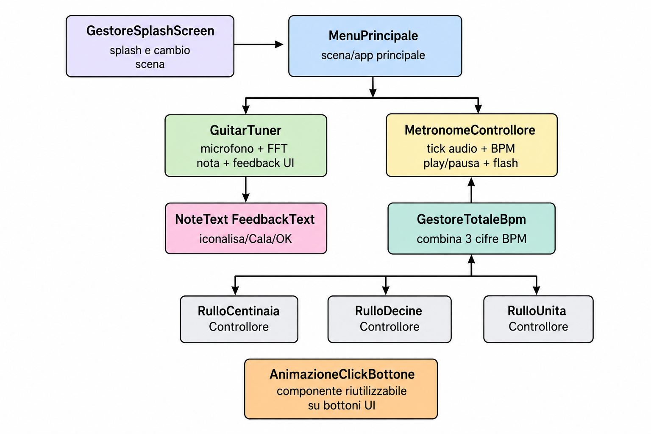

4. C# -> Python Mapping
C# element | Python translation | Notes
MonoBehaviour | class ... (MonoBehaviour) | Empty base class with minimal StartCoroutine and GetComponent implementations.
Start(), Update() | def Start(self), def Update(self) | Names preserved for literal correspondence with Unity.
public fields | public self attributes | Python does not have public/private access modifiers like C#.
private fields | self attributes | Preserved using similar naming, without visibility enforcement.
IEnumerator + yield return | Python generator with yield | Reproduces the coroutine structure, not the actual Unity timing behavior.
Color, Vector2, Vector3 | Python dataclass | Contain the minimal values and operators used by the code.
Mathf | Python static class | Implements Abs, Lerp, RoundToInt, Log, Pow, Clamp, Sin, and Exp.
GameObject.SetActive | SetActive(bool) method | Stores the activeSelf state.
AudioSource, AudioClip | Python stub | Preserve the main properties and method calls.
Permission / Microphone | Python stub | Preserve the microphone permission flow and initialization process.
SceneManager.LoadScene | Python stub | Stores the loaded scene state.

5. Script-by-Script Explanation

ControlloreRullo
Public fields: contentPanel is the container holding the numbers. snappingSpeed controls how quickly the roller centers itself. brakingThreshold determines when the residual velocity is low enough to force snapping. centerScale/sideScale and centerColor/sideColor define the appearance of central and side elements.
SelectedValue: Property containing the digit currently read from the roller. In C# it has a private setter; in Python it is a normal attribute due to language limitations.
Start(): Retrieves the ScrollRect, sets deceleration, determines the viewport, stores the contentPanel children inside numberRects, and starts MobileInitialization.
MobileInitialization(): Waits for the end of the frame, forces a layout rebuild, waits 0.1 seconds and, if at least 14 elements exist, centers index 2, which corresponds to the real zero.
Update(): Every frame it finds the number closest to the center. If it enters the fake copies at the extremes, it performs an invisible teleport toward the real indices. Then it updates graphics, selected value, and snapping.
InvisibleTeleport(): Calculates the vertical offset between fake and real elements, instantly moves the contentPanel, and copies scale/color values to hide the jump.
FindClosestIndexToCenter(): Iterates through all number RectTransforms, converts their position into the viewport local system, and selects the one with the minimum vertical distance from the center.
CenterIndex(): Calculates how much the contentPanel must move to bring the selected element to the center. If instant or with minimal offset, it moves immediately; otherwise it interpolates using Lerp.
UpdateVisualEffects(): For each number, determines whether it is central. The central element tends toward centerScale and centerColor; the others toward sideScale and sideColor.
ExtractValue(): Attempts to convert the object name into an integer. If successful, it updates SelectedValue.
OnPointerDown/OnDrag/OnPointerUp: Indicate whether the user is dragging. During dragging, automatic snapping must not block movement.

GestoreTotaleBpm
Fields: Contains references to the metronome and the three rollers: hundreds, tens, and units. currentBpm is used to avoid repeated calls if the value does not change.
Update(): Checks that the three rollers exist, calculates newBpm = hundreds*100 + tens*10 + units, enforces a minimum value of 1 and, if the value changes, calls metronome.SetBPM.

GuitarTuner
UI fields: noteText displays the note name; feedbackText displays the message and frequency. The three icons indicate sharpen, flatten, or perfect tuning.
Audio fields: audioSource captures microphone input. notes contains the twelve note names. spectrum is an array of 8192 spectrum samples. sampleRate is the audio sampling frequency.
Start(): Creates or retrieves AudioSource, enables looping and volume, sets noteText to white, disables icons, and requests microphone permission if missing.
Update(): If the microphone is not initialized but permission is available, it attempts startup. If active and AudioSource is playing, it analyzes the sound.
TryStartMicrophone(): Checks that microphone devices exist, reads supported frequencies, uses maxFreq or 48000, starts Microphone.Start, waits until the position becomes greater than zero, then starts AudioSource.
AnalyzeSound(): Fills spectrum, searches for the bin with maximum amplitude above threshold, checks divisors 4/3/2 to recover a lower fundamental frequency, refines the bin using interpolation, and converts the result into Hz.
UpdateUI(): Converts the frequency into a MIDI index relative to A4 = 440 Hz. Retrieves note name, target frequency, and pitch difference. Updates text, color, and icon depending on whether the note is correct, sharp, or flat.
HideAllIcons(): Disables raiseIcon, lowerIcon, and perfectIcon if present.
OnAudioFilterRead(): Clears the audio buffer to prevent the microphone signal from being played through the output.

MetronomeControllore
UI/audio fields: backgroundImage is used for the flash effect. playButton and pauseButton are alternated. tickSource plays activeTickClip, selected between defaultTickClip and alternativeTickClip.
Start(): If the default tick is missing, it creates it synthetically, then sets activeTickClip and the initial button state.
Update(): If the metronome is playing and DSP time exceeds nextTickTime, it plays the tick, starts the flash, and schedules the next tick with 60/bpm.
FlashBackground(): Saves the original color, sets the background to white for 0.05 seconds, then restores the original color.
ChangeSound(): Switches the active clip between default and alternative, if available.
StartMetronome(): Enables isPlaying, sets nextTickTime to the current audio time, and switches the play/pause buttons.
StopMetronome(): Disables isPlaying and restores the play/pause buttons.
SetBPM(): Clamps BPM between 1 and 999. If the metronome is running, it realigns the next tick to the new interval.
GetBPM(): Returns the current BPM.
ClosePanel(): Stops the metronome and disables the panel GameObject.
CreateSyntheticTick(): Creates a 0.1 second AudioClip at 44100 Hz with an 800 Hz sine wave and exponential decay.

AnimazioneClickBottone
Fields: pressedScale defines the button reduction, while speed controls how quickly the scale approaches the target.
Start(): Stores the initial transform scale and also uses it as the initial target scale.
Update(): Interpolates transform.localScale toward targetScale every frame.
OnPointerDown(): When the finger/mouse presses the button, sets targetScale to originalScale * pressedScale.
OnPointerUp(): When the finger/mouse is released, restores targetScale to the original scale.
OnPointerExit(): If the pointer exits the button before release, cancels the press and restores the original scale.

GestoreSplashScreen
Image fields: grandmotherImage and logoImage are the animated splash screen images.
Position/time fields: initialY/finalY determine the logo vertical movement. Timing values regulate delays, fades, and scene transition.
Start(): Forces the logo into the initial position and starts AnimationSequence.
AnimationSequence(): Executes in order: initial wait, grandmother fade-out, smooth logo movement, pause, logo fade-out, black screen wait, and scene loading.
SmoothStep: The formula ${progress}^{2}\left(3-2⋅progress\right)$ makes the movement smoother compared to pure linear interpolation.

6. Main step-by-step flows

6.1 Tuner
Start GuitarTuner
-> prepara AudioSource
-> spegne icone
-> richiede permesso microfono
Update GuitarTuner
-> se permesso OK e microfono non inizializzato: TryStartMicrophone
-> se microfono attivo: AnalyzeSound
AnalyzeSound
-> legge spettro FFT
-> trova bin massimo
-> corregge eventuale armonica cercando fondamentale
-> calcola frequenza Hz
-> se 60 < Hz < 1200: UpdateUI
UpdateUI
-> calcola nota piu vicina
-> confronta frequenza reale e frequenza target
-> aggiorna testo, colore e icona

6.2 Metronome BPM
Utente trascina i tre rulli
-> ControlloreRullo aggiorna ValoreSelezionato
GestoreTotaleBpm.Update
-> BPM = centinaia*100 + decine*10 + unita
-> se BPM < 1: BPM = 1
-> se BPM cambiato: MetronomeControllore.ImpostaBPM(BPM)
MetronomeControllore.Update
-> se isPlaying e dspTime >= nextTickTime
-> PlayOneShot(activeTickClip)
-> FlashBackground()
-> nextTickTime += 60/BPM

6.3 Splash Screen
Start
-> logo a yIniziale
-> StartCoroutine(SequenzaAnimazione)
SequenzaAnimazione
-> attesa tempoIniziale
-> alpha nonna 1 -> 0
-> logo yIniziale -> yFinale con SmoothStep
-> pausa tempoLogoFermo
-> alpha logo 1 -> 0
-> attesa nero
-> SceneManager.LoadScene(nomeScenaGioco)

7. Notes on the literal Python translation
Python coroutines are generators, but they do not include Unity’s frame-by-frame scheduling engine.
AudioSettings.dspTime is simulated using time.time(), therefore it does not match Unity’s real audio precision.
Microphone, Permission, AudioSource, TextMeshProUGUI, GameObject, and SceneManager are stubs: they preserve method calls and internal state, but not the native functionalities.
The FFT is not actually computed: the stub AudioSource.GetSpectrumData can receive an external spectrum provider, but it does not capture real audio.
RectTransform, ScrollRect, and LayoutRebuilder do not calculate real graphical layouts; they are used to preserve names and execution flow.
Where C# uses private fields or private set properties, Python uses normal attributes because privacy is convention-based.

8. Screenshots

8.1 Loading with grandma
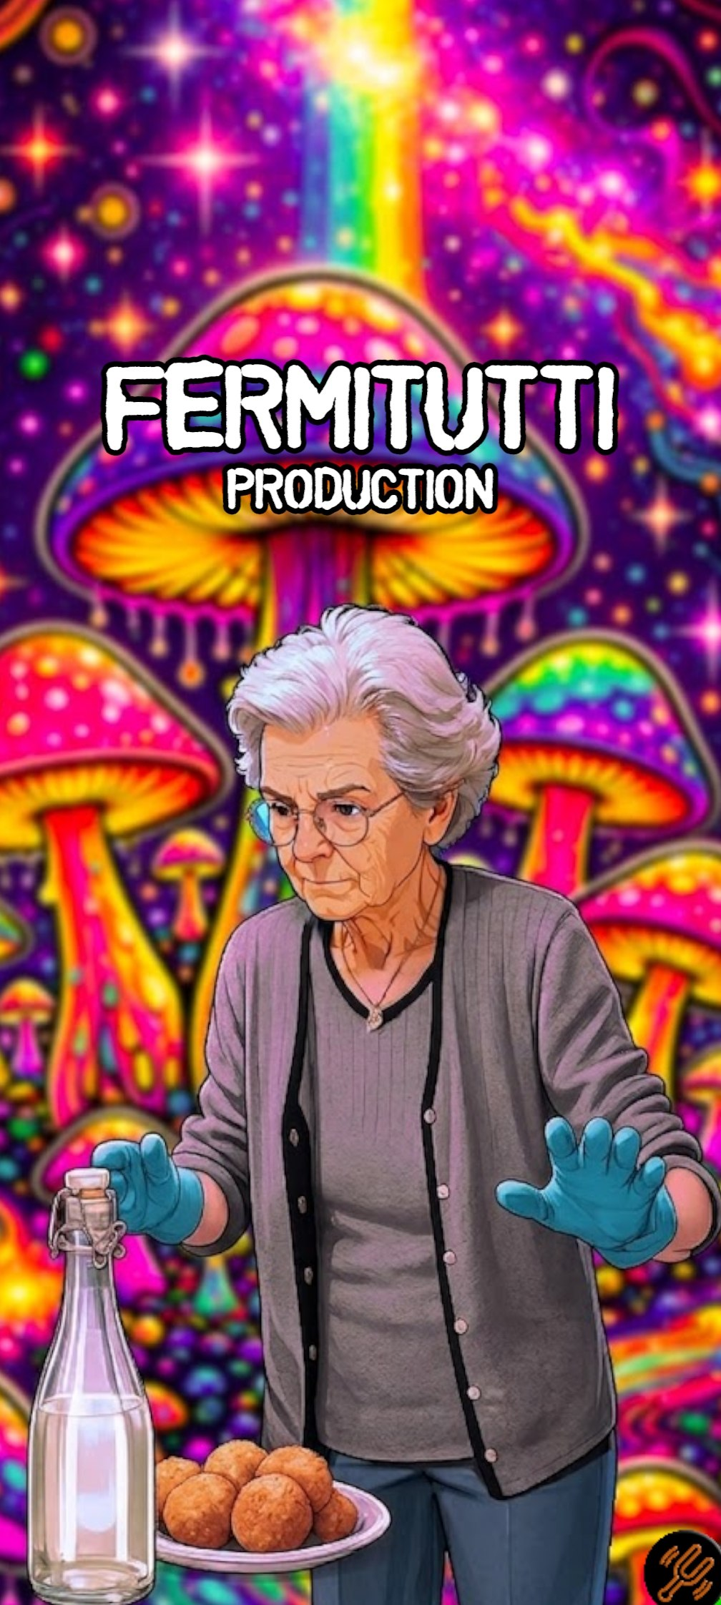

8.2 Press the popping button to enter the app

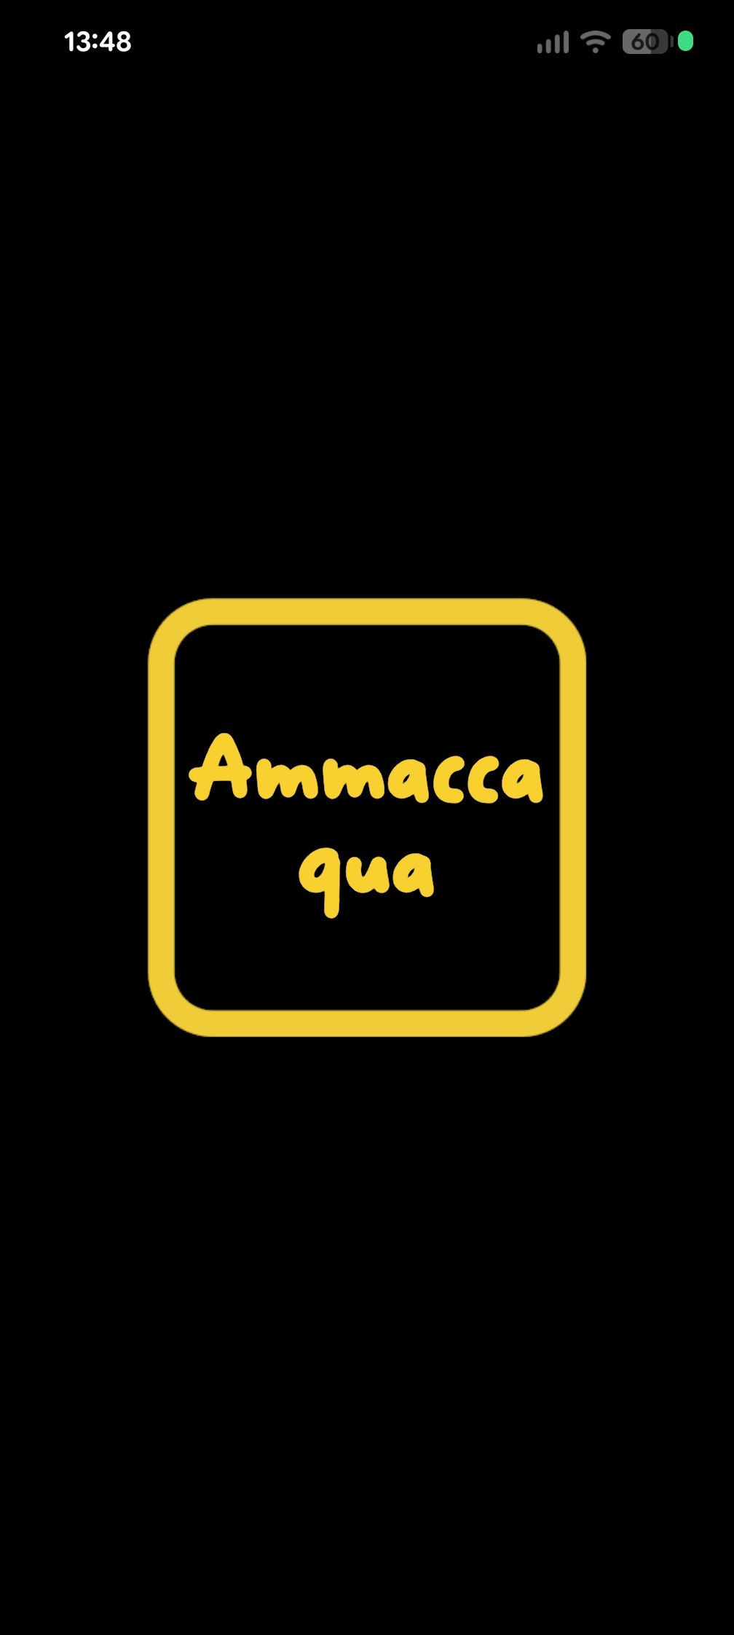

8.3 The Tuner

8.3.1 The note is lower 8.3.2 The note is perfect 8.3.3 The note is higher

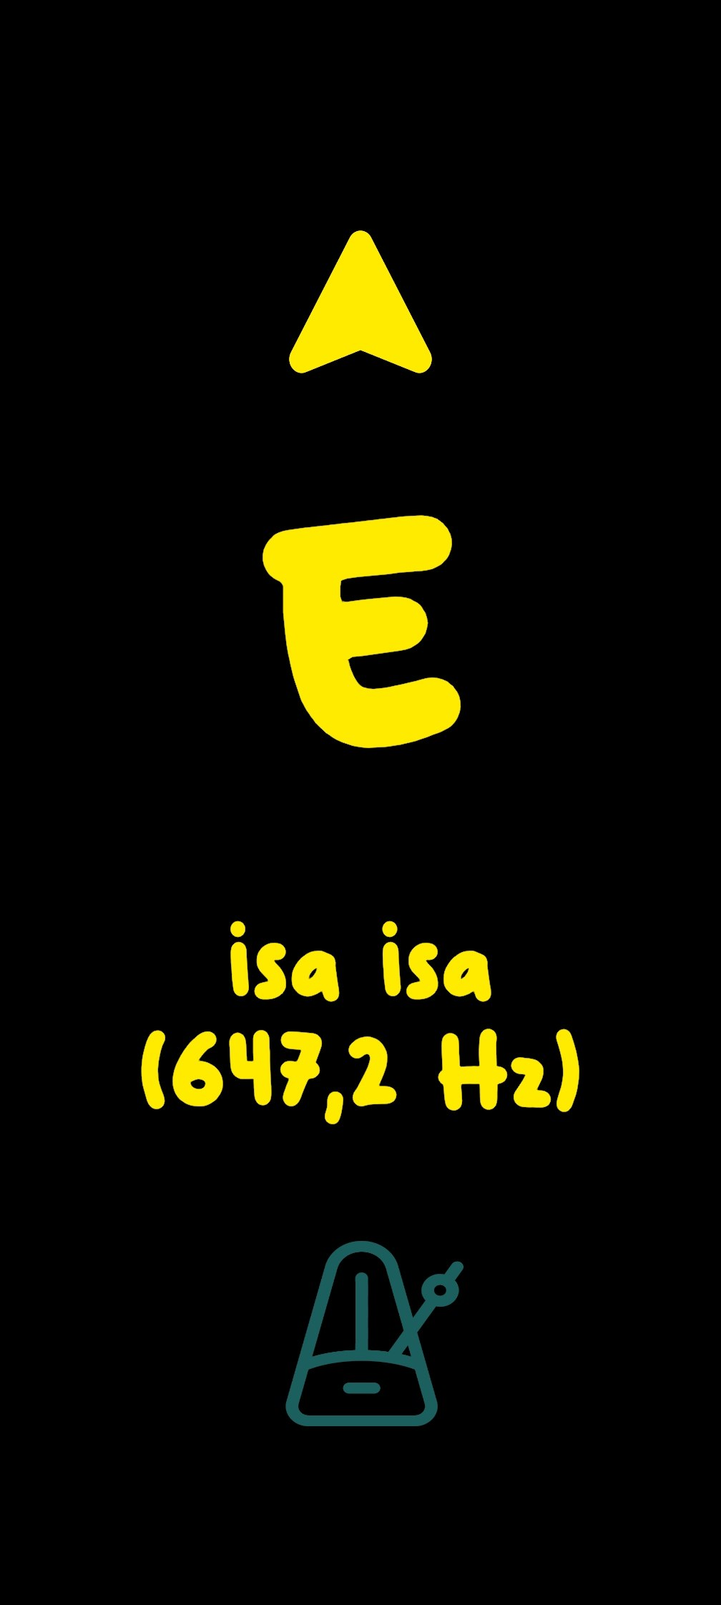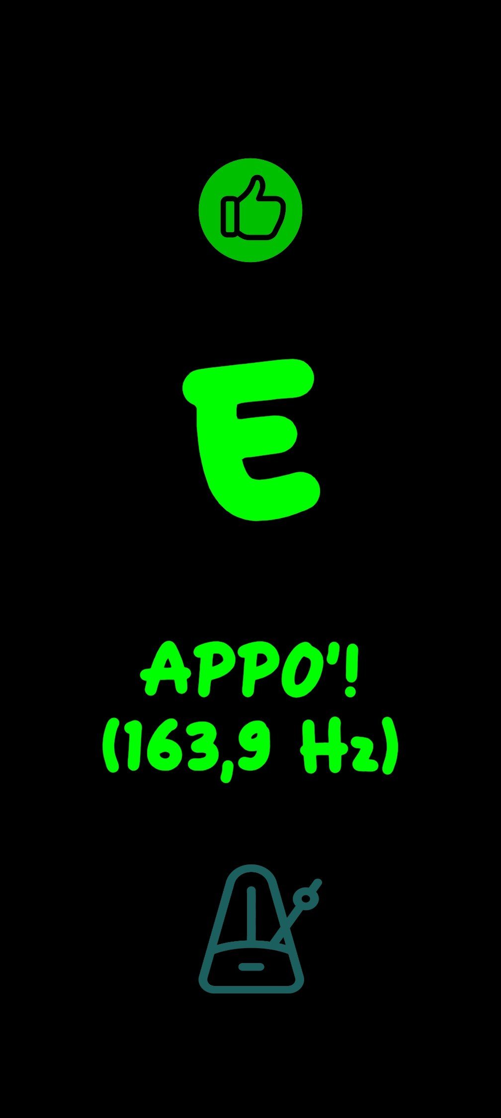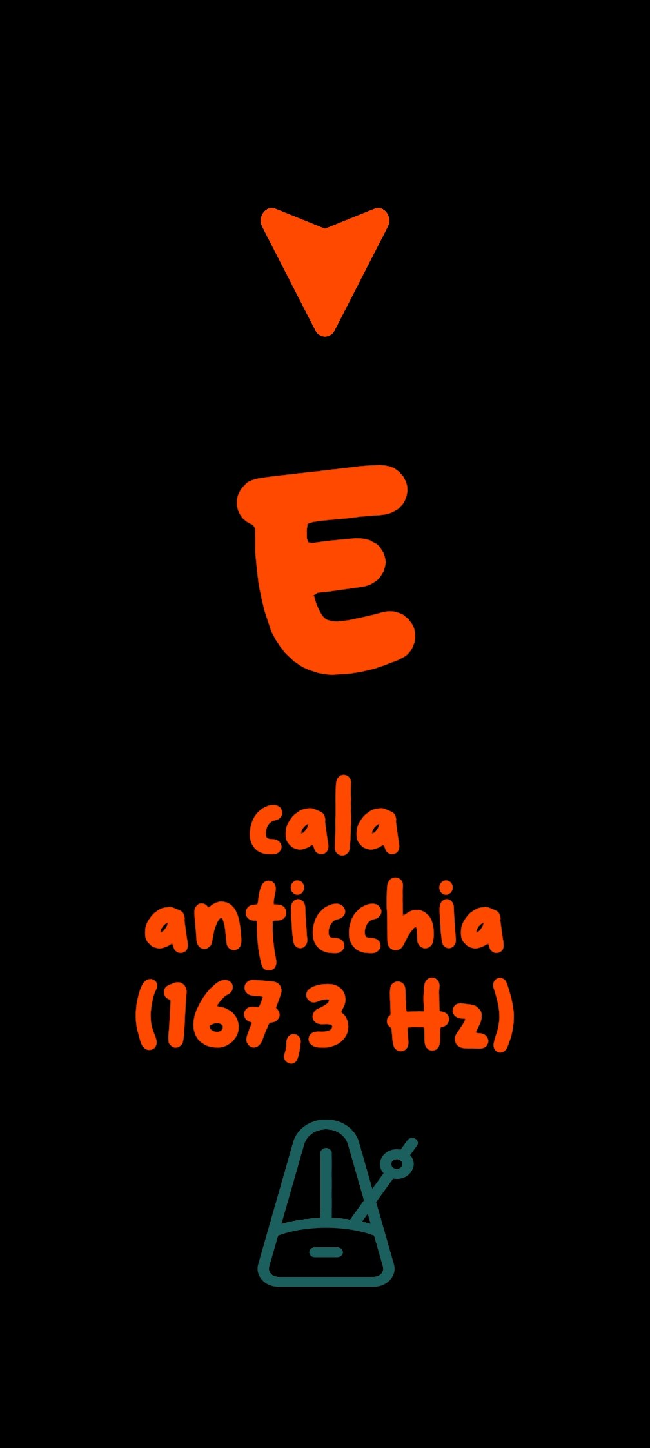

8.4 The Metronome
(You enter the metronome by clicking the icon under the note)
